**Step 1: Create New Workflow**

1. Log into your automation platform
2. Click "Create New Workflow" or "New Scenario"
3. Give your workflow a descriptive name (e.g., "Daily Report Email")

**Step 2: Add Schedule Trigger**

1. **Add Trigger Module**
   * Search for "Schedule" or "Timer" trigger
   * Select the schedule trigger option
2. **Configure Schedule Settings**
   * Choose frequency: Daily, Weekly, Monthly, or Custom
   * Set specific time (e.g., 9:00 AM)
   * Select timezone
   * Choose start date

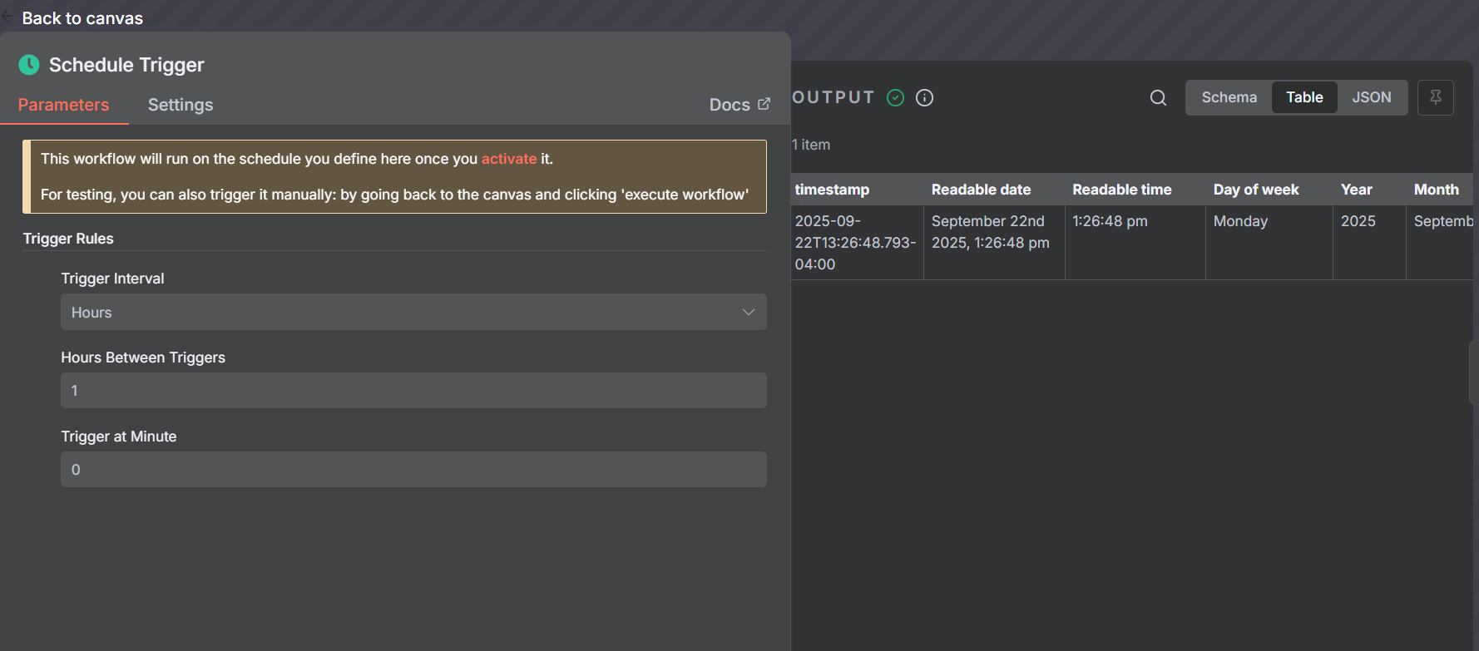

**Important Note**: No need to use console.cloud for schedule triggers. Most automation platforms have built-in scheduling that doesn't require Google Cloud Console setup.

**Step 3: Set Up Gmail Module**

1. **Add Gmail Module**
   * Search for "Gmail" in modules
   * Select "Send an Email" action

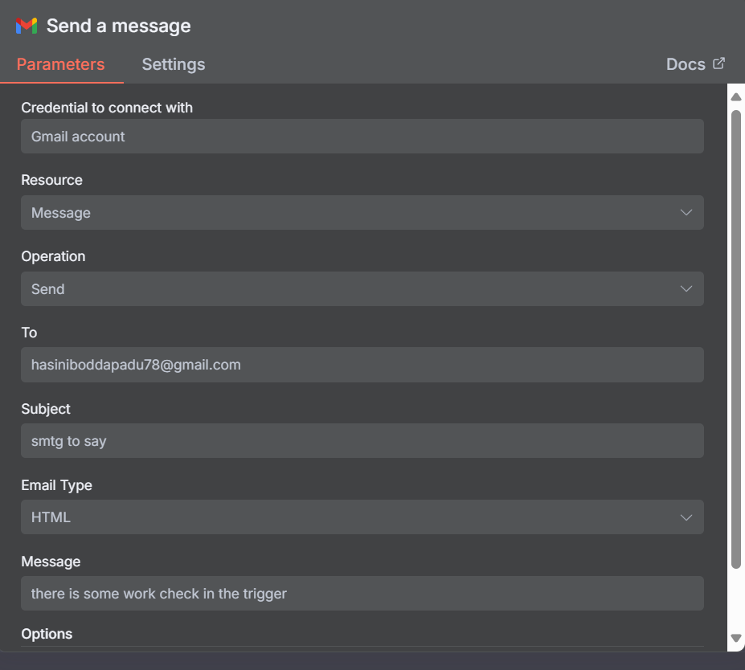

1. **Authenticate Gmail Account**
   * Click "Create a connection"
   * Sign in with your Gmail account
   * Grant necessary permissions
   * Test connection

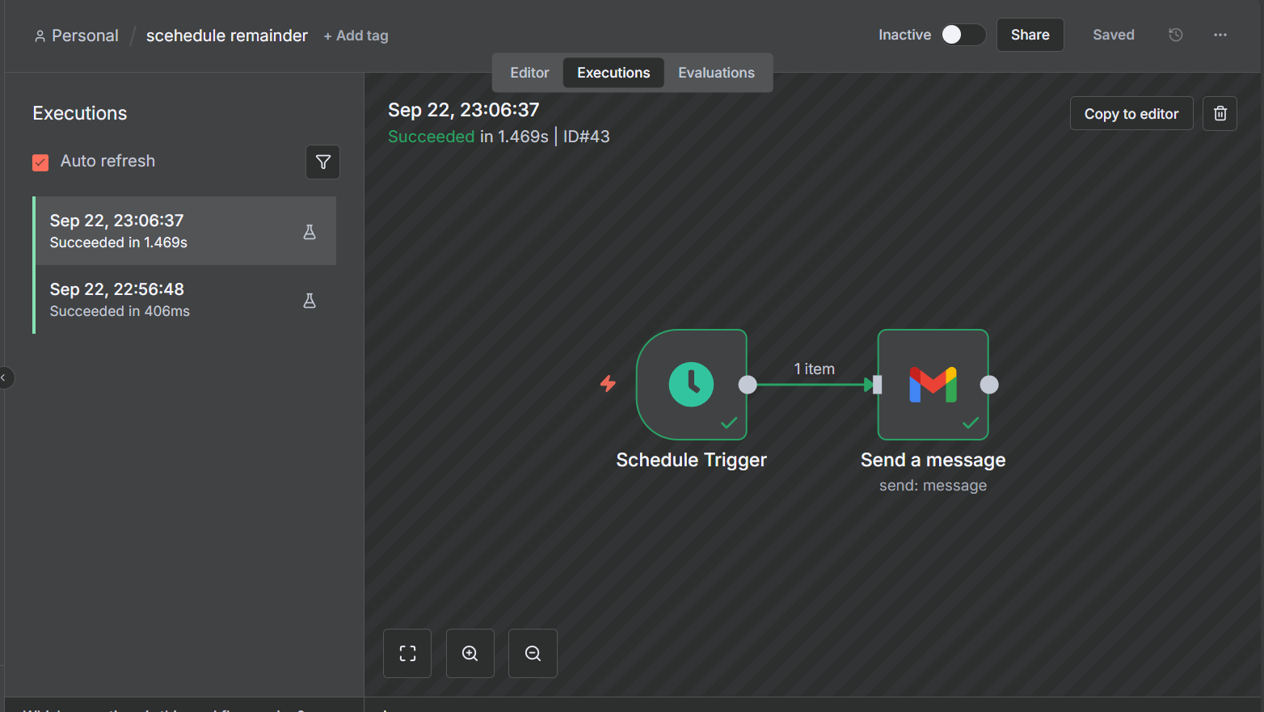

We get an email for every hour like this as we kept the limit for every hour.

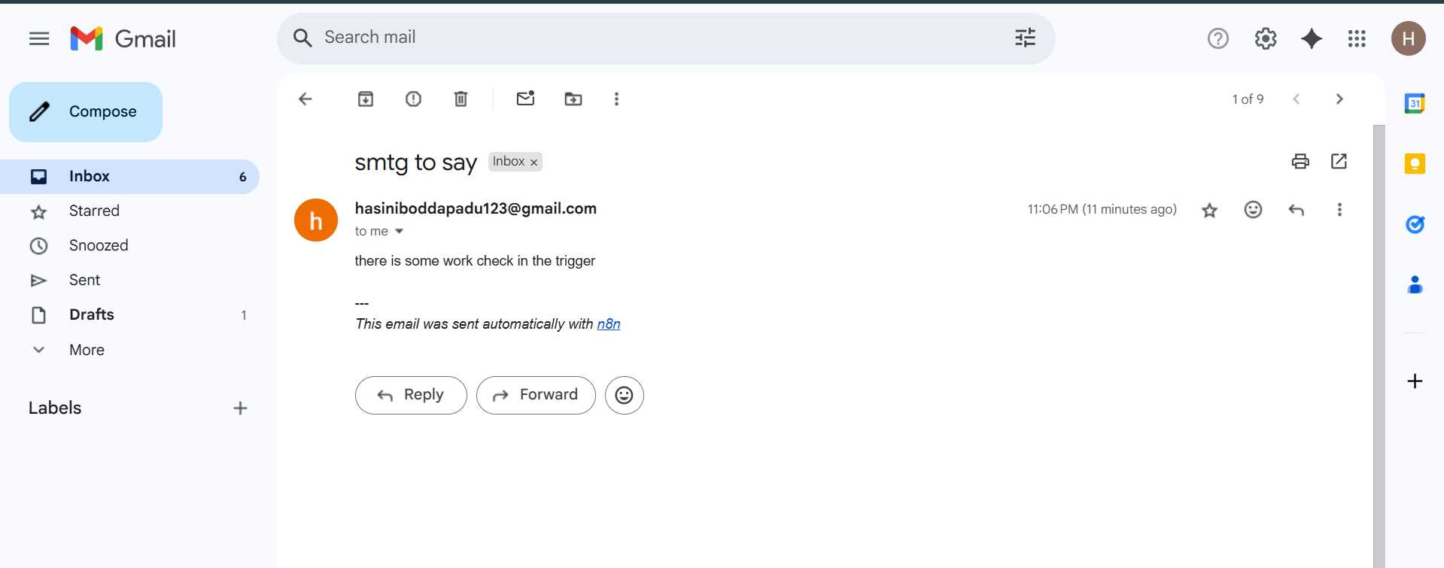

**Google AI Studio API Key - When and How**

**When You Need Google AI Studio API Key**

**You DON'T need it for:**

* Basic Gmail sending (uses OAuth)
* Simple data processing
* Standard workflow operations
* Most automation tasks

**You DO need it when:**

* Integrating Google's Gemini AI models
* Using Google's generative AI capabilities
* Making direct API calls to Google AI services
* Building custom AI-powered features

**How to Generate Google AI Studio API Key**

**Step-by-Step Process:**

1. **Access Google AI Studio**
   * Go to [aistudio.google.com](https://aistudio.google.com)
   * Sign in with your Google account
2. **Navigate to API Keys**
   * Click on your profile/account icon
   * Select "Get API key" or "API keys"
   * Or look for "API access" in settings
3. **Create New API Key**
   * Click "Create API key"
   * Choose the appropriate Google Cloud project
   * Copy the generated API key immediately
   * Store it securely (you won't see it again)
4. **Configure API Key Usage**
   * Set usage limits if needed
   * Configure allowed applications
   * Enable specific AI models
   * Set billing preferences